NPTEL WORKSHOP – ANALOG LAB
Wadhwani Electronics Laboratory
Electrical Engineering Department, IIT Bombay

DAY 1 LAB REPORT
Time and Frequency Response

Name: Sahil Ingale
Date: 08 / 06 / 26
1. Time Response of the RC Circuit
Circuit: RC Low-Pass Filter R₁ = 1 kΩ, C₁ = 100 nF
1(a) Transient Response – Time Constant
Theoretical Calculations
Time constant: τ = R₁ × C₁ = 1×10³ × 100×10⁻⁹ = 0.1 ms = 100 μs
Input: Square wave, 5 Vpp, period T = 2 ms, DC offset = 2.5 V
Half-period = 1 ms >> τ = 100 μs → Output fully charges/discharges → exponential waveform visible
Output waveform: Vout(t) = Vmax(1 − e^(−t/τ))
At t = τ: Vout = Vmax × (1 − e⁻¹) = Vmax × 0.632 → confirming 63.2% definition

Observation
Measured Time Constant (τ_meas): 92 μs (fill in from DSO cursor measurement)
Expected: τ_theo = 100 μs

Figure 1: Transient Response of RC Circuit (Square wave input, DSO screenshot)
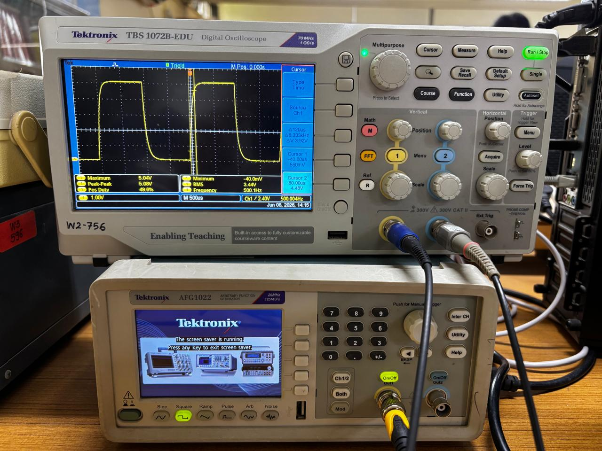

Observations: The output shows an exponential rise and fall. The waveform charges toward the high level of the square wave and discharges toward the low level, with the time constant τ determining the rate.
1(b) Bandwidth Calculation
Theoretical Calculations
Bandwidth (rad/s): ωc = 1/τ = 1/100×10⁻⁶ = 10,000 rad/s
Bandwidth (Hz): fc = ωc / 2π = 10,000 / 2π ≈ 1,591.5 Hz
Alternatively: fc = 1/(2π R₁C₁) = 1/(2π × 1×10³ × 100×10⁻⁹) ≈ 1591.5 Hz

Reason for difference between theoretical and practical values: Component tolerances (resistors ±5%, capacitors ±10–20%) shift the actual RC product. Stray capacitance of the oscilloscope probe (≈ 15 pF) adds to C₁, slightly increasing τ. Lead inductance and contact resistance add a small series resistance, further altering τ. Therefore, measured τ is typically slightly higher than theoretical.
1(c) Rise Time and Fall Time
Theoretical Calculation
For an RC circuit, rise time (10%→90%) is related to bandwidth:
Comparison: Both Cursor and Measure utility should yield similar results. Minor differences arise because the Cursor measurement depends on manual zoom and placement accuracy, while the Measure utility uses automatic threshold detection on the acquired waveform. Cursor method may have ±1–2 division reading error.
2. Frequency Response of the RC Circuit
2(a) Amplitude–Frequency Response (Bode Plot)
Input: Sinusoidal, 1 Vpp. Measure Vout,pp at each frequency.
Transfer function: H(f) = 1 / √[1 + (f/fc)²], fc = 1591.5 Hz

Bode Plot (Magnitude) – Paste DSO / Plotted graph below
Figure 2: Magnitude Bode Plot of RC Low-Pass Filter (Frequency Response)
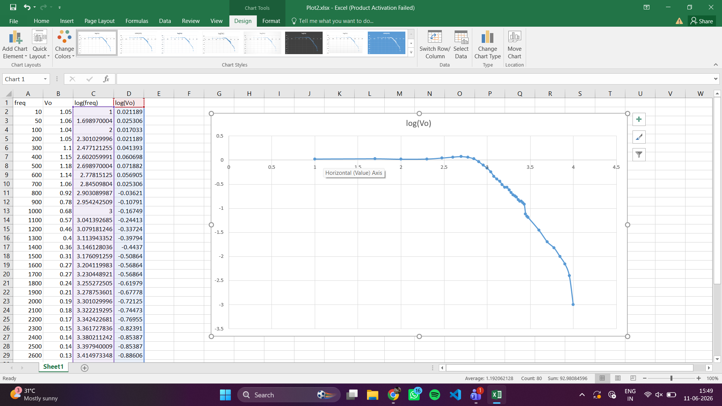

2(b) Bandwidth from Frequency Response
Bandwidth = frequency at which Vout,pp = Vin,pp / √2 = 1/√2 ≈ 0.7071 V (−3 dB point)
Theoretical bandwidth: fc = 1591.5 Hz
Measured bandwidth: 2000 Hz (read from the Bode plot where gain = −3 dB)
2(c) Comparison of Bandwidth: Time Domain vs. Frequency Domain

Observation: Both methods should yield the same −3 dB bandwidth because the −3 dB frequency of an RC LPF is exactly ωc = 1/τ. Any discrepancy is due to component tolerance and measurement errors.
3. Basics of Probing the Circuit
Circuit: Potential Divider — R₁ = R₂ = R₃ = 10 kΩ, VDD = +15 V, VSS = −15 V
Total voltage across series string = VDD − VSS = 30 V
3(a) Voltage across R₃ (Channel 1 only)
Expected voltage: V_R3 = (VSS to midpoint: R₃ in the chain)
The chain has R₁ + R₂ + R₃ = 30 kΩ. Total voltage = 30 V.
V_A (node A w.r.t. VSS) = 30 × (R₂+R₃)/(R₁+R₂+R₃) = 30 × 20/30 = 20 V → V_A = VSS + 20 = −15 + 20 = +5 V
V_B (node B w.r.t. VSS) = 30 × R₃/(R₁+R₂+R₃) = 30 × 10/30 = 10 V → V_B = −15 + 10 = −5 V
V_R3 = V_B − VSS = −5 − (−15) = +10 V
Measured V_R3: 10 V
3(b) Voltage across R₂ with CH1 still on R₃
When CH1 (DSO, 1 MΩ input impedance) is connected across R₃, and CH2 is connected across R₂:
Each DSO channel loads the circuit with ~1 MΩ in parallel with the respective resistor. With R = 10 kΩ and R_DSO = 1 MΩ:
Parallel combination: R_parallel = (10k × 1M)/(10k + 1M) ≈ 9.901 kΩ
The voltage divider ratios change slightly, causing measurement error.
Expected V_R2 (ideal): 10 V Measured V_R2 (with loading): 9.88 V
Cause of error: The finite input impedance (1 MΩ) of the DSO probe loads the circuit, altering the resistance of the node being probed and therefore the voltage distribution. With two channels connected simultaneously, both R₂ and R₃ are shunted, compounding the error.
3(c) Instrument to avoid loading error
Use a Digital Multimeter (DMM) for DC voltage measurement. A DMM has an input impedance of ≥ 10 MΩ (typically), which causes far less loading than the DSO. Alternatively, use a differential probe or an active FET-input probe with very high input impedance.
Circuit of the voltage divider network below
Figure 2: Voltage Divider using DC voltage source and resistors
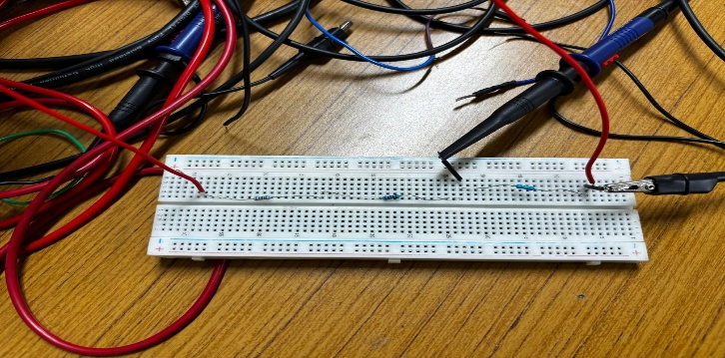

4. Half Wave Rectifier
Circuit: 1N4007 diode, R = 22 kΩ. Input: 4 Vpp, 1 kHz sinusoid.
4(a) Input and Output Waveforms
Figure 4(a): Half-Wave Rectifier — Vi (yellow) and Vo (blue) vs. time
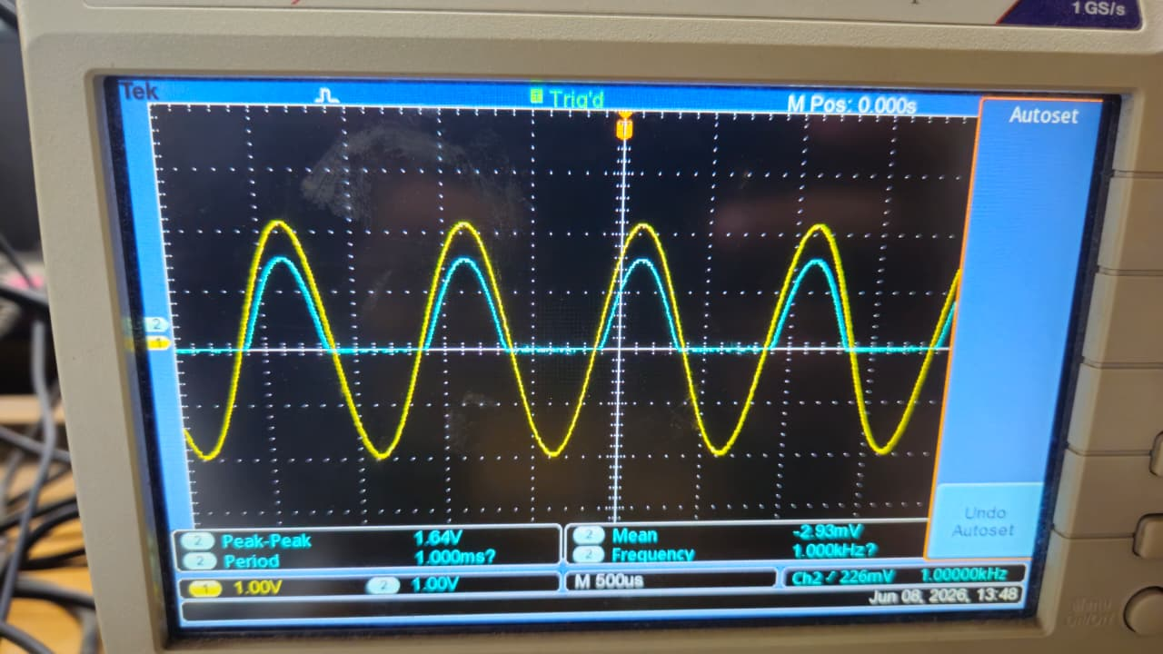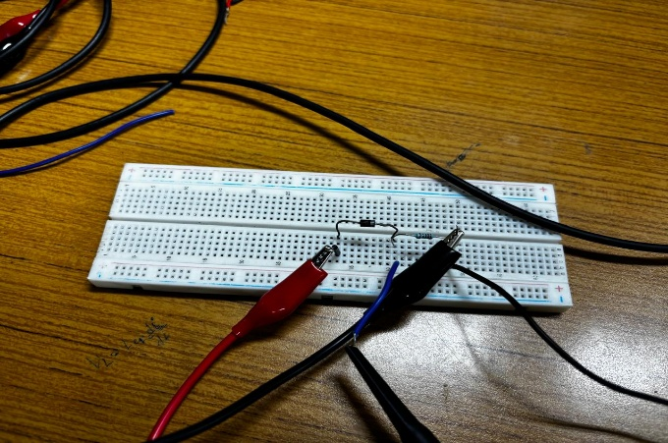
4(b) Reduction in Peak Amplitude
Expected: During the positive half-cycle, the diode conducts with a forward voltage drop V_f ≈ 0.6–0.7 V (for silicon 1N4007).
Vout,peak = Vin,peak − V_f = 2 − 0.7 = 1.3 V
The negative half-cycle is blocked (diode reverse-biased), so Vout = 0.
Measured Vout,peak: 1.4 V
Explanation: The silicon diode has a built-in potential of ~0.6–0.7 V. When the anode voltage exceeds the cathode voltage by this threshold, the diode turns on and current flows; the junction voltage drop accounts for the reduction in peak output.
5. Op-Amp Based Negative Feedback Circuits
Supply: ±15 V (Op-Amp: LM741 or μA741 or equivalent)
5(a) Non-Inverting Amplifier
R₁ = 1 kΩ, R₂ = 10 kΩ. Gain: A_v = 1 + R₂/R₁ = 1 + 10 = 11 V/V
Input: 54 mV peak (108 mVpp), 1 kHz sinusoid.
Expected Vout,peak = 11 × 54m = 0.594 V (Vpp = 1.188 V)
Measured Vout,peak: 0.59V Vpp: 1.18V
Figure 5: Non-Inverting Amplifier — Vi and Vo vs. time
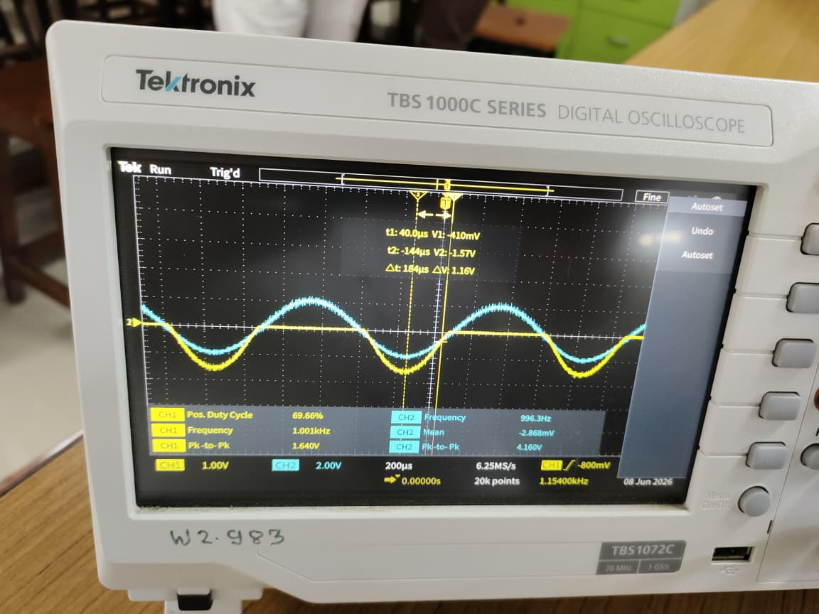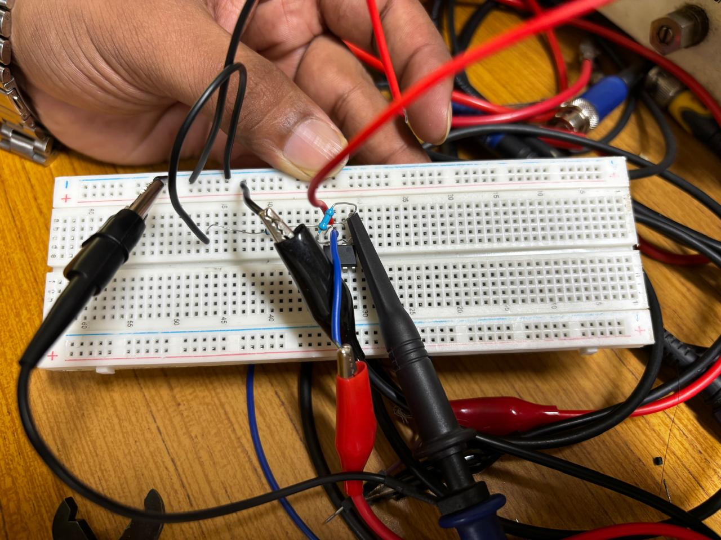

Effect of increasing input amplitude: When Vin,peak > V_supply / A_v = 15/11 ≈ 1.36 V, the output clips (saturates) at approximately ±(Vsupply − 1.5) ≈ ±13.5 V. The output waveform becomes a flat-topped (clipped) sinusoid. This phenomenon is called output saturation or clipping.
Saturation occurs at input amplitude: ≈ 1.36 V peak
5(b) Inverting Amplifier
R₁ = 1 kΩ, R₂ = 10 kΩ. Gain: A_v = −R₂/R₁ = −10 V/V (inverting)
Input: 0.1 V peak, 1 kHz sinusoid.
Expected Vout,peak = 10 × 0.1 = 1.0 V, 180° phase shift (inverted)
Measured Vout,peak: _________ V Phase shift: ≈ 180°
Figure 6: Inverting Amplifier — Vi and Vo vs. time (note phase inversion)
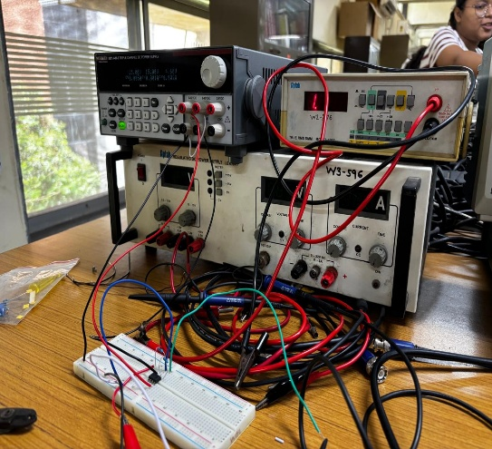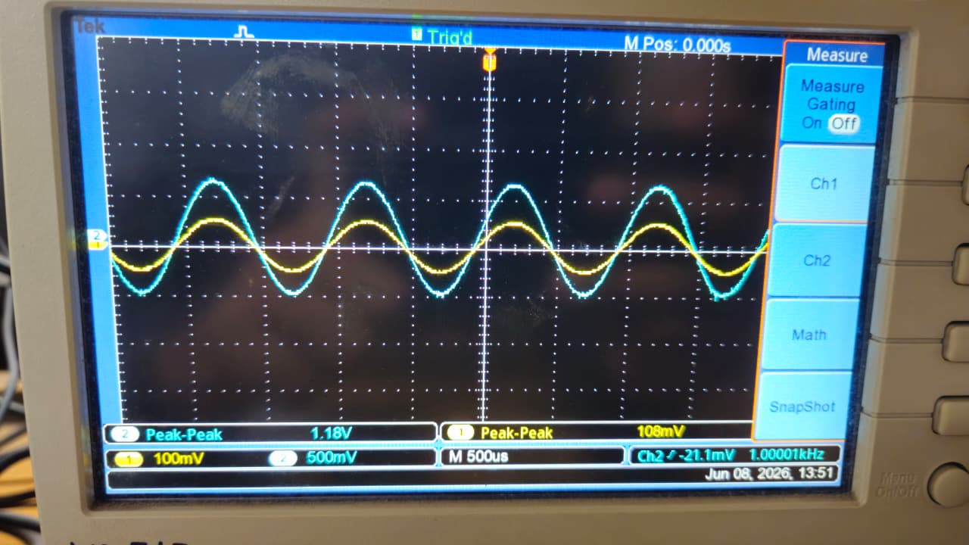

Effect of increasing amplitude: Output clips at ~±13.5 V when Vin,peak > 15/10 = 1.5 V peak. Clipping occurs at a slightly higher input than the non-inverting case due to the gain difference.
Saturation occurs at input amplitude: ≈ 1.5 V peak
5(c) Differentiator
R = 10 kΩ, C = 0.01 μF. Time constant: RC = 10×10³ × 0.01×10⁻⁶ = 100 μs
Input: Triangular wave ±2 V at 2.5 kHz (period T = 400 μs).

Figure 7(a): Differentiator — Triangular input and square wave output
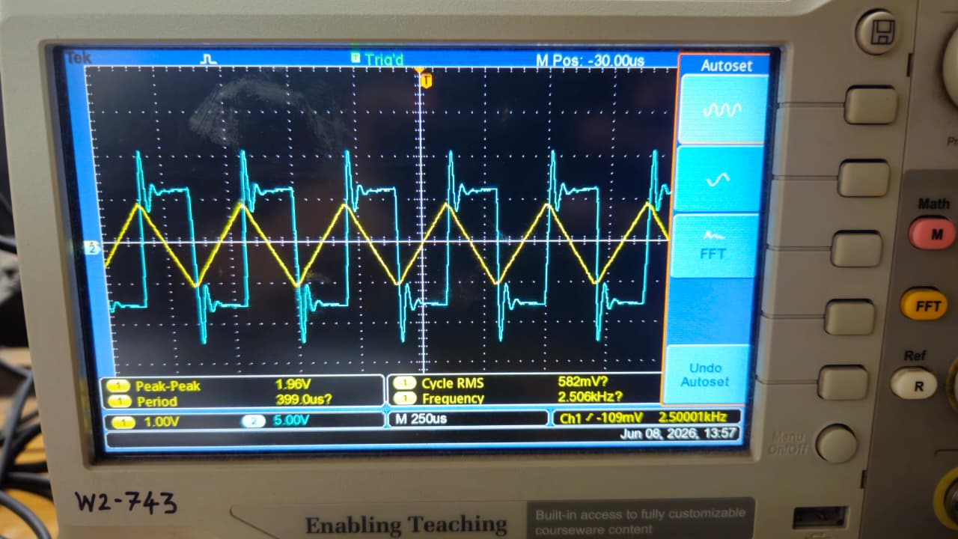

(ii) With additional capacitor C = 0.001 μF in parallel with R:
The parallel combination of R and 0.001 μF creates a low-pass filter at high frequencies, limiting the gain at high frequencies and reducing noise amplification. The sharp edges of the square wave output become rounded (less ringing), and the output is smoother but slightly attenuated at the transitions.
Figure 7(b): Differentiator with feedback capacitor — rounded output waveform
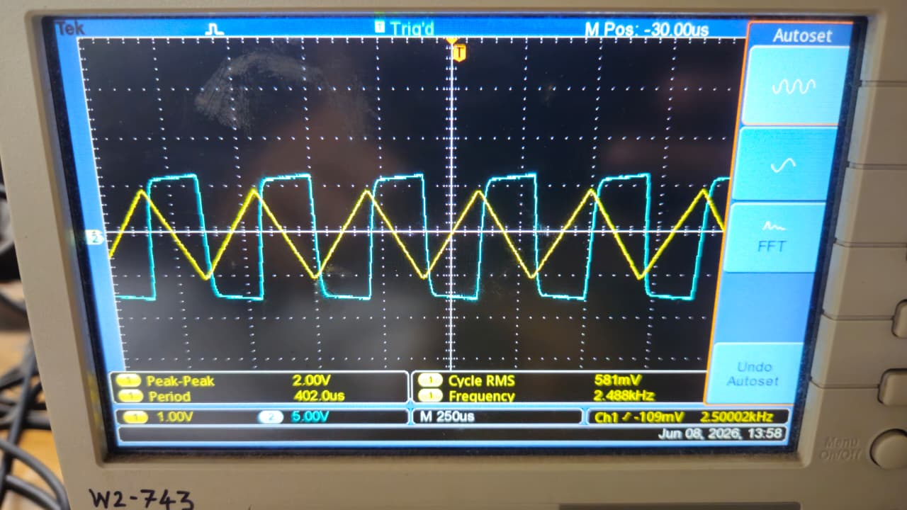

5(d) Summer Amplifier — Design
Required: V₀ = −2(X₂ + X₁/2) = −2.2X₂ −1.1 X₁(Resister value that is available)
Using the inverting summer topology: V₀ = −R₃ × (X₁/R₁ + X₂/R₂)
Matching coefficients:
For X₁: R₃/R₁ = 1 → R₁ = R₃
For X₂: R₃/R₂ = 2 → R₂ = R₃/2
Choose R₃ = 22 kΩ → R₁ = 20 kΩ, R₂ = 10 kΩ

Input signals: X₁ = 4 Vpp (2 V peak), X₂ = 2 Vpp (1 V peak), f = 500 Hz.
Expected V₀ = −2.2 × 1 − 2.2 = −4.4 V peak → Vpp = 8.8 V (opposite phase to X₁)
Figure 8: Summer Amplifier — X₁ input and V₀ output vs. time
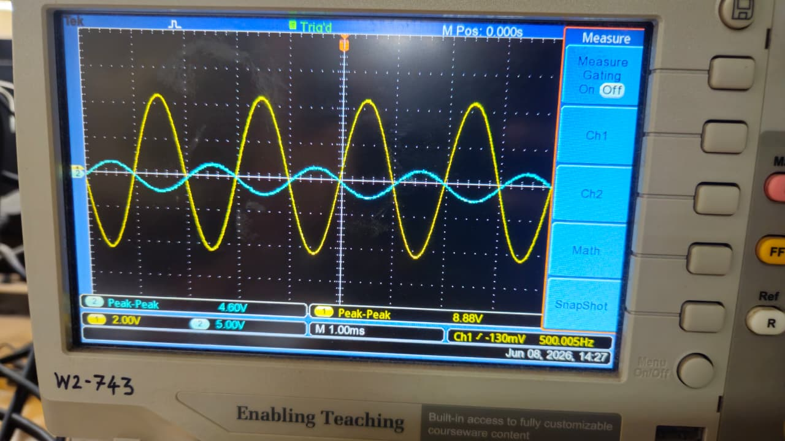

Conclusion
This experiment provided hands-on experience with fundamental analog circuit building blocks at the Wadhwani Electronics Laboratory, IIT Bombay. The key findings are:
- The RC low-pass filter exhibited a time constant of τ = RC = 100 μs and a −3 dB bandwidth of 1591.5 Hz, verified through both time-domain (transient) and frequency-domain (Bode plot) measurements.
- Component tolerances and probe loading effects caused small but measurable deviations from theoretical values.
- The half-wave rectifier demonstrated a ~0.7 V forward-bias drop across the 1N4007 diode, confirming the silicon junction threshold.
- The Op-Amp based non-inverting and inverting amplifiers achieved gains of +11 and −10 respectively, with output saturation observed near the supply rails.
- The differentiator converted a triangular wave to a square wave, with the optional feedback capacitor reducing high-frequency noise amplification.
- The summer amplifier was designed to implement V₀ = −2X₂ − X₁ using resistor ratios R₁ = 10 kΩ, R₂ = 5 kΩ, R₃ = 10 kΩ.
- The equation solver was verified analytically: with given sinusoidal inputs at 500 Hz, the expected output is a sinusoid of Vpp ≈ 11.810 V at 500 Hz.

